Updated Strategy Optimization with SMA
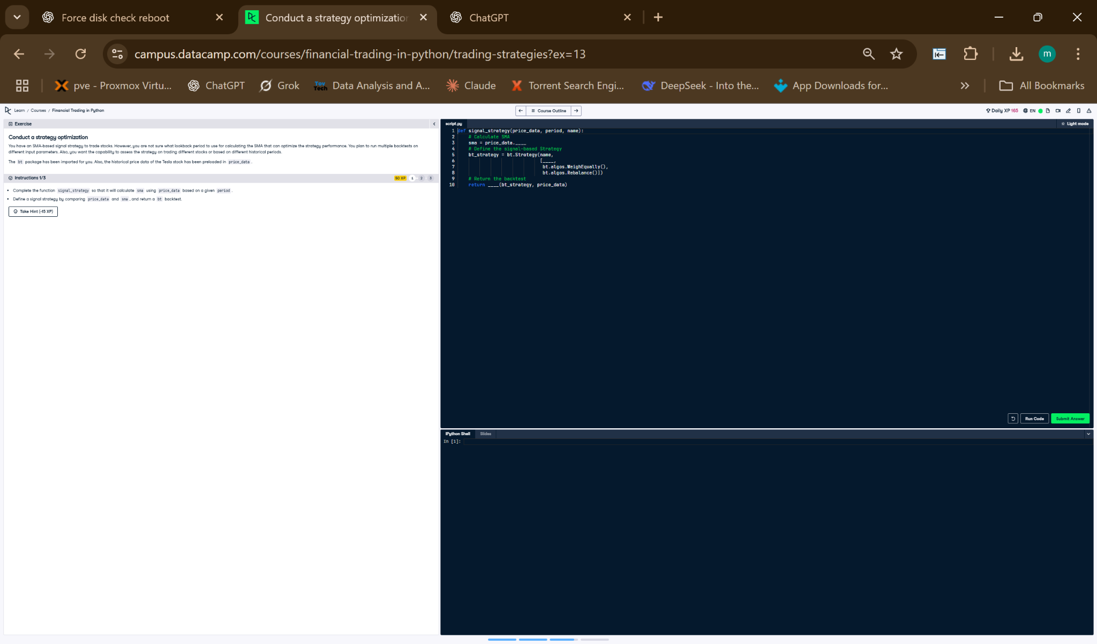

Updated Python Code
def signal_strategy(price_data, period, name):
# Calculate SMA
sma = price_data.rolling(period).mean()
# Define the strategy
s = bt.Strategy(name,
[bt.algos.SelectWhere(price_data > sma),
bt.algos.WeighEqually(),
bt.algos.Rebalance()])
# Return the backtest
return bt.Backtest(s, price_data)

Updated Explanation
This function calculates a simple moving average (SMA), then creates a strategy that picks stocks trading above their SMA. It assigns equal weight to selected stocks and rebalances the portfolio. The result is a backtest object used to evaluate the strategy’s performance.

